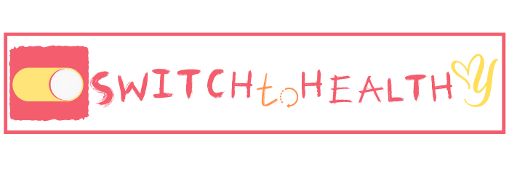 | 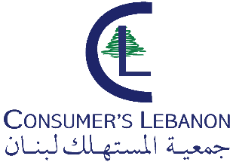

In Activity related to SWITCHTOHEALTHY project
and under the patronage of his excellency the minister of environment in Lebanon Dr. Nasser Yassin
Consumers Lebanon organize workshop in collaboration with Amwaj of the environment and Tyr coastal Natural reserve entitled:
“Food and sea turtles in the Mediterranean region”

Date: Saturday 4 February 10:00AM
Place: Tyr City house

