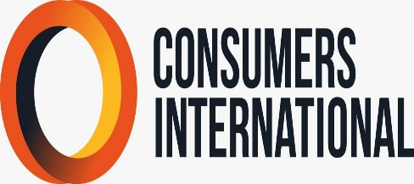 | 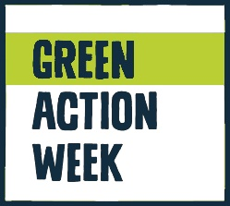

GREEN ACTION WEEK 2022

Project summary

Let’s Talk Compost! Aims to raise awareness of communities toward circular economy and composting. In addition to preventing food waste from its origin, CL will advocate and spread knowledge about the composting and is benefits at household level, to reduce food waste. Instead of throwing the organic waste in trash that in Lebanon goes to landfills CL will motivate the reuse of this organic waste generated by food waste to transform it in compost, which will be used for their gardening. CL will use different tools such as conducting podcasts, flyers, and brochure and disseminate it through different media platforms and within municipalities and schools.
Let’s Talk compost! seeks to reduce the final disposal of municipal waste in landfills, promoting families at household level to use their organic waste to produce compost, in order to migrate to a more efficient and environment-friendly circular economy. The specific objectives of this project are: • Raising awareness on the importance of the effects of the food waste problem on the environment and on the climate. • Promote the circular economy concept by conducting small activities such as composting at home. • Sharing with consumers the importance of composting and the different ways of composting from food
During September:
• Activity 1: Preparation of campaign materials (graphics, photos, flyers, brochure)
• Activity 2: Develop a simple communication plan.
• Activity 3: Collaboration of media, and other platform supporting circular economy do our campaign on time.
During October:
• Activity 4: Seminars at schools and universities.
• Activity 5: holding podcasts, dissemination of information and material about food waste, composting and circular economy, through media coverage and other platforms,
• Activity 6: Media coverage about the project during the Green action week.
• Activity 7: Evaluation and report

