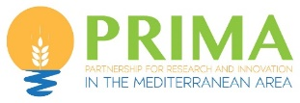

A new EU – PRIMA project just started: “SWITCHtoHEALTHY” Switching Mediterranean consumers to Mediterranean sustainable healthy dietary patterns.
SWITCHtoHEALTHY project started on 1st April 2022 as part of the PRIMA Program funded by the European Union under the Grant Agreement number 2133 - Call 2021 Section Agrofood IA, coordinated by ENCO srl – an Italian company specialized in innovation management and EU-funded projects.
SWITCHtoHEALTHY involves 18 prestigious organizations - public and private - from 8 countries of both shores of Mediterranean Sea (Italy, Egypt, Spain, Greece, Lebanon, Morocco, Tunisia and Turkey).
SWITCHtoHEALTHY project – with a duration of 36 months – aims to generate a dietary behaviour change by demonstrating and reinforcing the role of the family in promoting a sustainable change towards enhancing the adherence to the Mediterranean dietary pattern of the family members (adults, adolescents, and children). This will be done by making available to families a combination of hands-on educational material and digital tools and complementing the dietary and lifestyle recommendations with easy-to-eat healthier snacking products.
In this approach, whereas digital interactive tools (SWITCHtoHEALTHY App) will be used by the parents to support them in preparing weekly healthier dietary plans for the main meals for them and their children, the educational material will be used to support families in acquiring healthier habits and to educate children and adolescents. Finally, healthy, and nutritious plant-based snacks will be introduced in the children dietary plans to complement it and to substitute less healthier options in-between meals.
SWITCHtoHEALTHY will result in increasing the adherence to Mediterranean Diet (MD) by taking an intra-familiar systemic approach taking the family context into account and assess mutual influence of children/adolescents-parents and their roles in healthy eating and lifestyle; developing innovative solutions (plant -based snacks) based on proximity of ingredients, sustainability and healthy consumption to support agri-food producers (especially SMEs) in finding new business opportunities; job creation opportunities and diversification in traditional Mediterranean food sector; supporting food companies in getting through the barriers to market uptake and achieving a sustainable competitive advantage by designing innovative consumer-oriented BMs; raising awareness of the healthy benefits derived from a high adherence to a MD, increasing knowledge on local Med products thus contributing to improve healthy food choices among families; synergising cross-sectorial policy coherence across agriculture, health, education, environment, trade, etc. from local to national and international level and discussing with all actors of society.
A virtual Round Table was held online on April 14th and ENCO will host the onsite meeting on 25th and 26th May in Naples.
ENCO SRL (ENCO); Università degli Studi di Parma (UNIPR); Regione Campania (RC); Confederation of Egyptian European Business Associations (CEEBA); Fundació Eurecat (EUT); Centro Nacional de Tecnología y Seguridad Alimentaria (CNTA); Centre de Recerca en Economia i Desenvolupament Agroalimentari UPC-IRTA (CREDA); DELAFRUIT S.L.U. (former GO FRUSELVA S.L) (DELAFRUIT); Departament d’Acció Climàtica, Alimentació i Agenda Rural (DACC); Centre for Research and Technology Hellas (CERTH); Consumers' Lebanon (CONS); Unité Mixte de Recherche Nutrition et Alimentation (CNESTEN); Université Mohammed Premier (UMP); CHOCORICA (CHOCO); Association SLOW FOOD Tebourba (SLOW F); Bursa Uludag University (BUU); Gökhan Koca Kocahan Şekerleme (KOC); Izmir Provincial Directorate of Culture and Tourism (KTB).

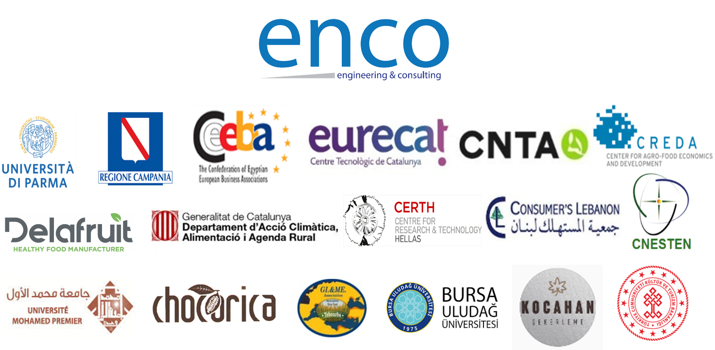
The SWITCHtoHEALTHY project is part of the PRIMA Programme supported by the European Union under the Grant Agreement number 2133.

Project Coordinator  Simona Mincione (ENCO SRL)  mincione@enco-consulting.it | Scientific & Technical Coordinator  Noemí Boqué Terre (EURECAT)  noemi.boque@eurecat.org

